Secondary Math 3 Lite Name____________________________________________

HW 3-4 Graphing Radicals Date____________________________________

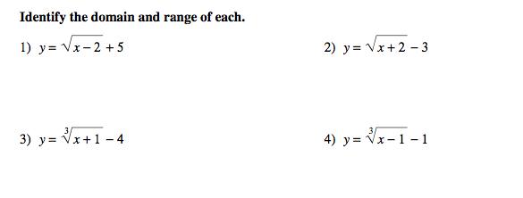

**Sketch the graph of each function.**

5)  6) 

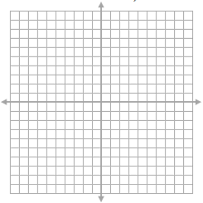 

7)  8) 

 

9)  10) 

 

11)  12) 

 

13. **State the domain and range:** 14) **State where is the graph increasing and decreasing.**

 

